How to log into your WEX account

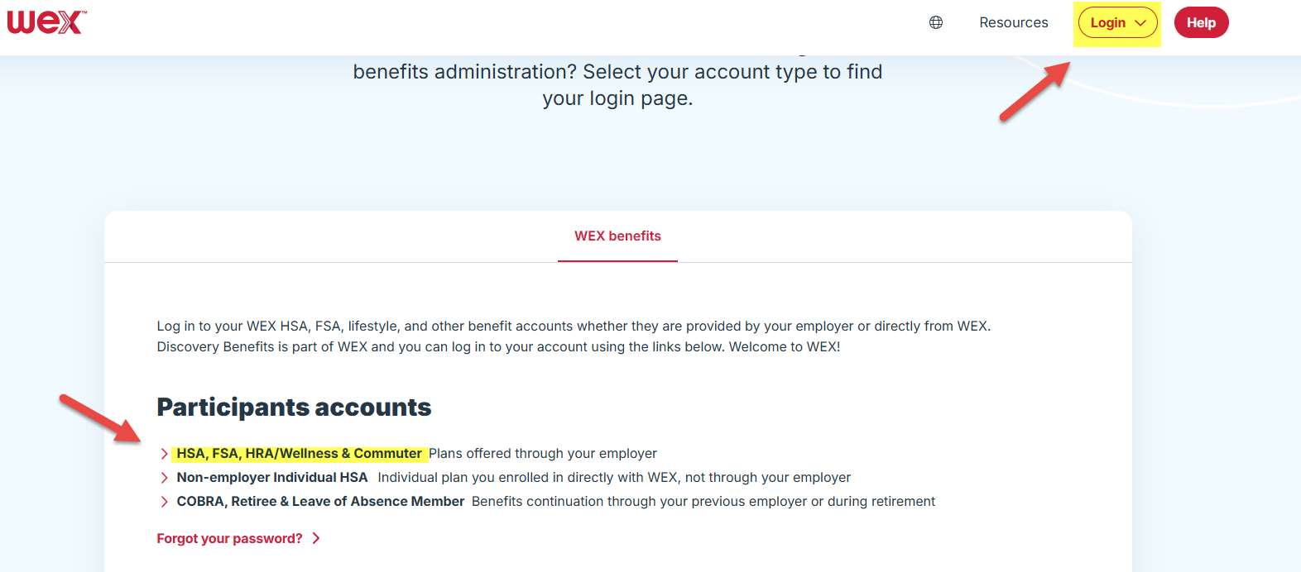

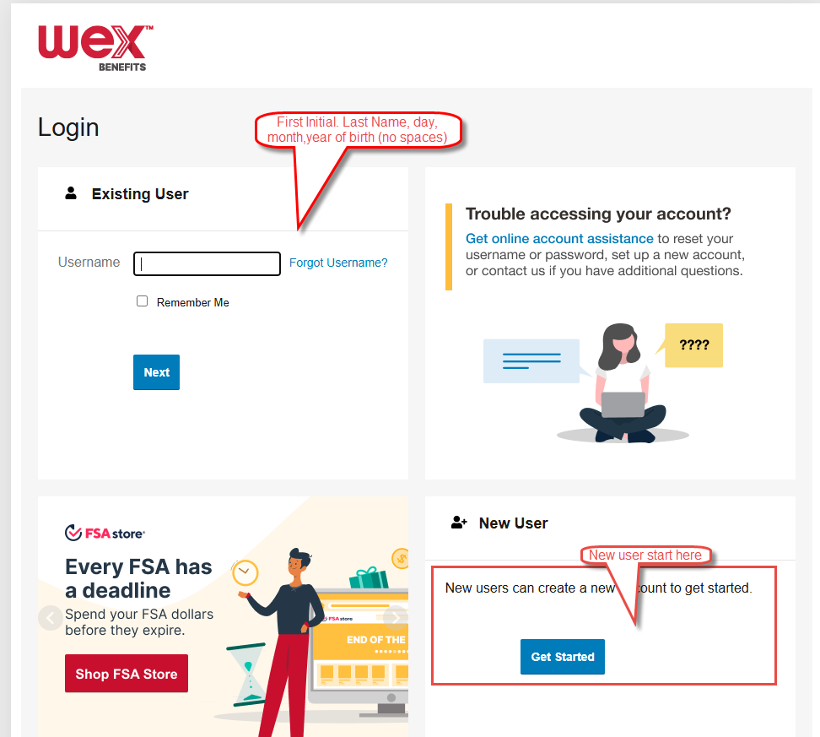

Username example: Jane Doe, DOB 10/06/1971 = jdoe061071

Enter password. If you forgot your password, use the link next to username for assistance